

SIMATS ENGINEERING

Saveetha Institute of Medical and Technical Sciences
Chennai- 602105

Student Name: DHANUSH KUMAR R Reg. No.: 192411215
Course Code: CSA4301 Slot: B
Course Name: INTERNET PROGRAMMING
Course Faculty: Dr. Marie Claude
Project Title: Homemade Foods — A Digital Marketplace for Homemade Food Products
Module Photographs:
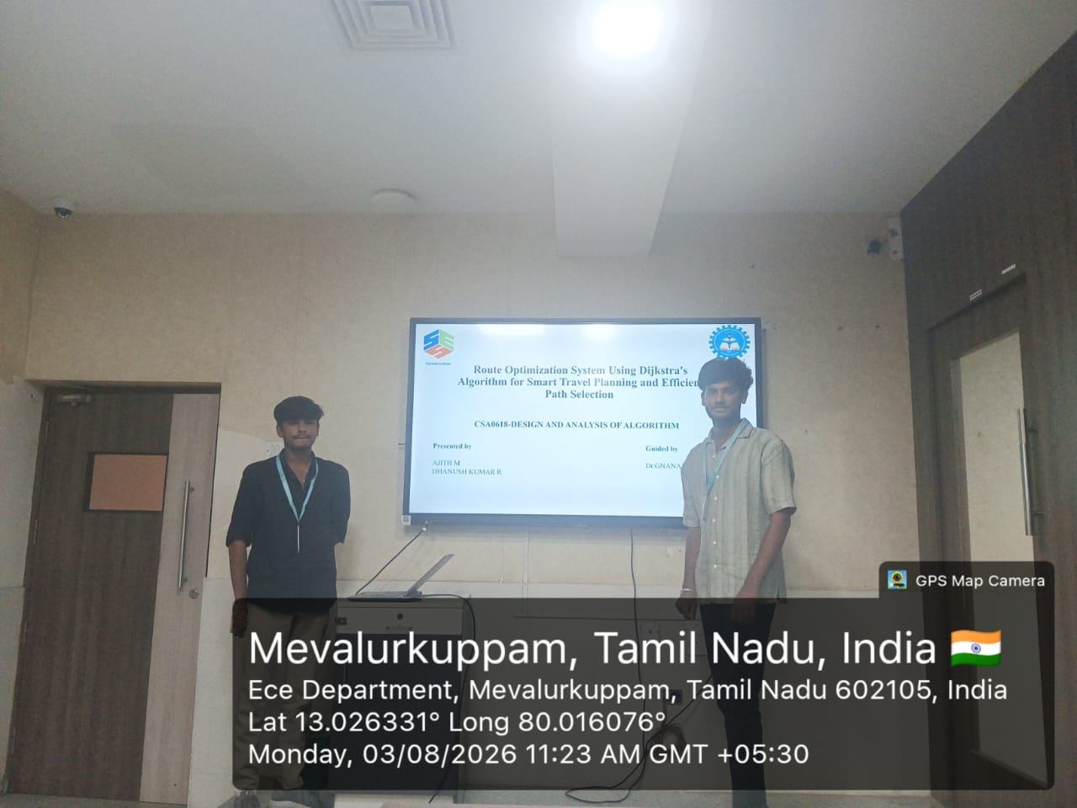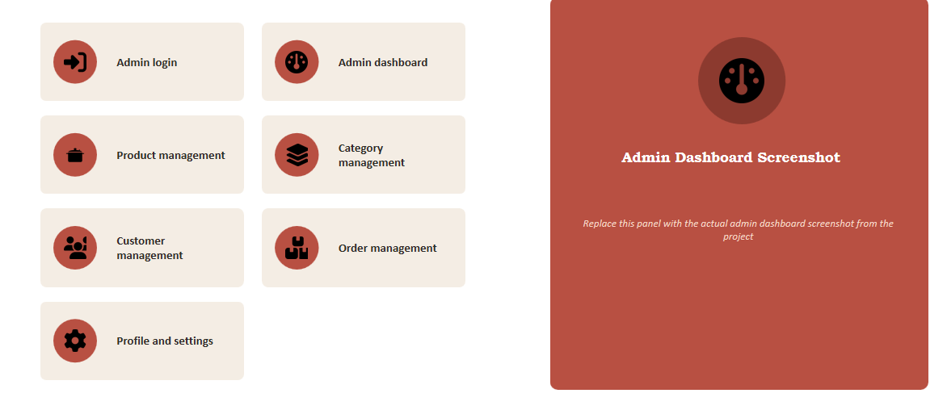

Project Description: (here you write what you did in this project (contribution) including Model Description
Homemade Foods — A Digital Marketplace for Homemade Food Products is a web-based application developed to provide an online platform for buying and selling homemade food products. The system connects customers with homemade food sellers and allows sellers to display their products with details such as name, description, price, and availability. Customers can easily browse different food items, search for their preferred products, view product information, add items to their cart, and place orders online. The platform provides a simple and user-friendly interface for managing products, customers, and orders. This project demonstrates the use of Internet Programming concepts such as HTML, CSS, JavaScript, web forms, database connectivity, user authentication, and server-side processing to develop an interactive and functional online marketplace.

Student Signature Guide Signature

